Practical 12:

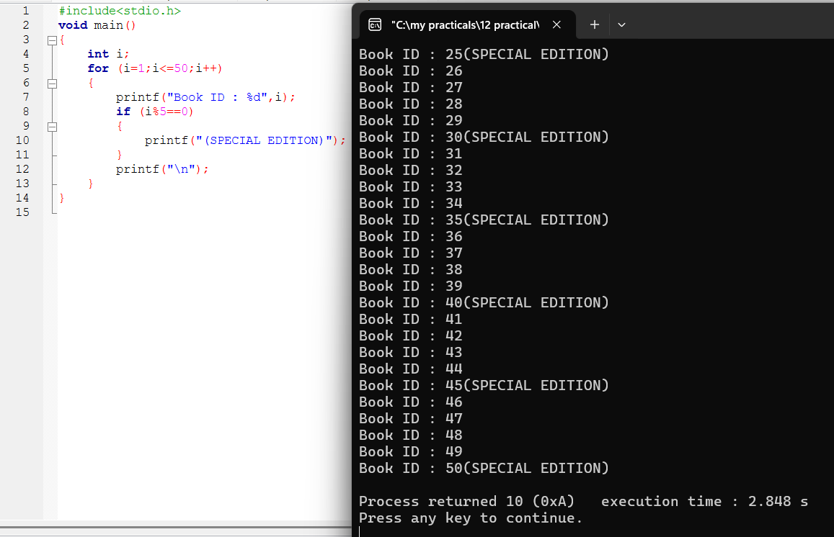

12-i:

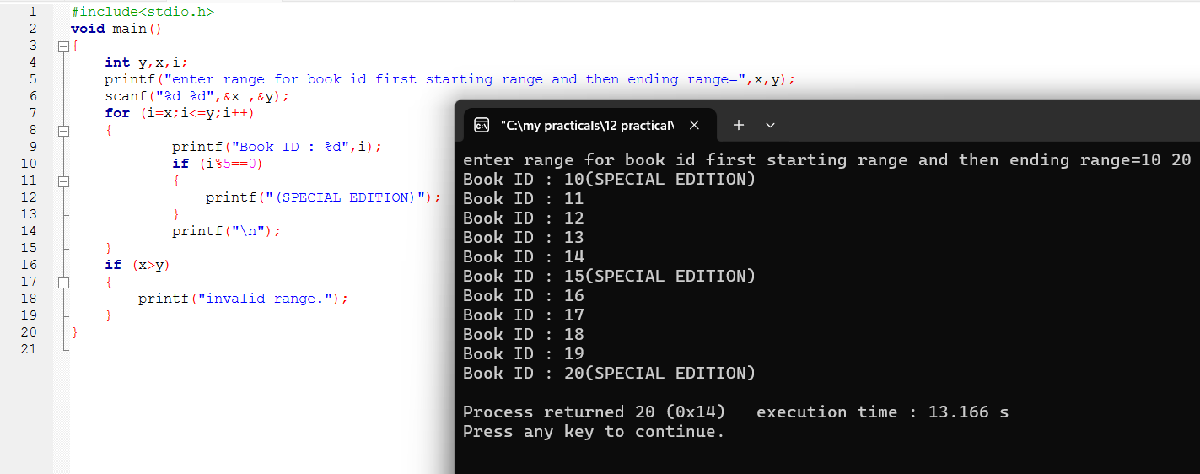

12-ii:

12-iii:

